Eye Disease Detection Using Deep Learning

## Project Description:

### In this project we are classifying various types of Eye Diseases that people get due to various reasons like age, diabetes, etc. These diseases are majorly classified into 4 categories namely Normal, cataract, Diabetic Retinopathy & Glaucoma. Deep-learning (DL) methods in artificial intelligence (AI) play a dominant role as high-performance classifiers in the detection of the Eye Diseases using images.

Transfer learning has become one of the most common techniques that has achieved better performance in many areas, especially in image analysis and classification. We used Transfer Learning techniques like Inception V3, VGG19, XceptionV3 and Resnet50 that are more widely used as a transfer learning method in image analysis and they are highly effective.

## Technical Architecture:

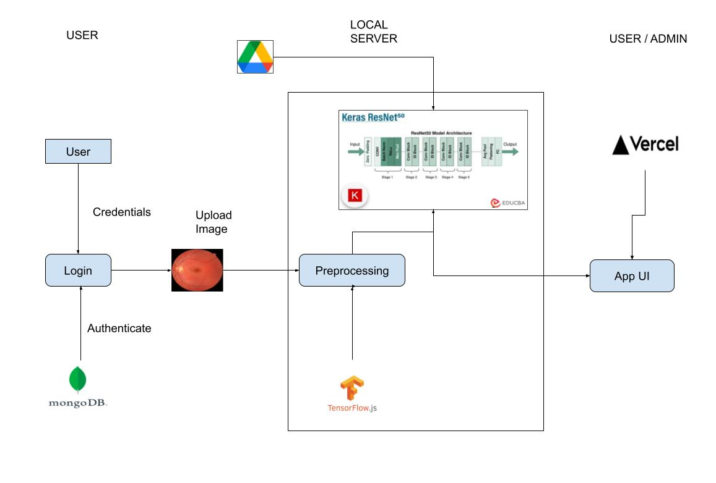

**Project Flow:**

* The user interacts with the UI (User Interface) to choose the image.
* The chosen image analyzed by the model which is integrated with flask application.
* The Resnet50 Model analyzes the image, then the prediction is showcased on the Flask UI.

To accomplish this, we have to complete all the activities and tasks listed below

* Data Collection.
  + Create a Train and Test path.
* Image Pre-processing.
  + Import the required library
  + Configure ImageDataGenerator class
  + Apply ImageDataGenerator functionality to Trainset and Testset
* Model Building
  + Pre-trained CNN model as a Feature Extractor
  + Adding Dense Layer
  + Configure the Learning Process
  + Train the model
  + Save the Model
  + Test the model
* Application Building
  + Create an HTML file

# Prior Knowledge:

You must have prior knowledge of following topics to complete this project.

#### Deep Learning Concepts

o **CNN:** <https://towardsdatascience.com/basics-of-the-classic-cnn-a3dce1225add>

#### VGG19: [VGG-19 convolutional neural network - MATLAB vgg19 - MathWorks India](https://in.mathworks.com/help/deeplearning/ref/vgg19.html)

* **ResNet-50V2:**

[**https://towardsdatascience.com/understanding-and-coding-a-resnet-in-keras-446d7ff84d33**](https://towardsdatascience.com/understanding-and-coding-a-resnet-in-keras-446d7ff84d33)

o **Inception-V3:** <https://iq.opengenus.org/inception-v3-model-architecture/>

#### o Xception:

[**https://pyimagesearch.com/2017/03/20/imagenet-vggnet-resnet-inception-xception-keras/**](https://pyimagesearch.com/2017/03/20/imagenet-vggnet-resnet-inception-xception-keras/)

* **Flask:** Flask is a popular Python web framework, meaning it is a third-party Python library used for developing web applications.

Link: [**https://www.youtube.com/watch?v=lj4I_CvBnt0**](https://www.youtube.com/watch?v=lj4I_CvBnt0)

**Build Python Code**

**Project Structure:**

### Create a Project folder which contains files as shown below

* The Dataset folder contains the training and testing images for training our model.
* For building a Flask Application we needs HTML pages stored in the **templates** folder,CSS for styling the pages stored in the static folder and a python script **app.py** for server side scripting
* The IBM folder consists of a trained model notebook on IBM Cloud.
* Training folder consists of eye_disease_classification_resnet50.ipynb model training file & edc_final.pb is saved model

# Milestone 1: Data Collection

There are many popular open sources for collecting the data. Eg: kaggle.com, UCI repository, etc.

**Activity 1: Download the dataset**

Collect images of Eye Diseases then organize into subdirectories based on their respective names as shown in the project structure. Create folders of types of Eye Diseases that need to be recognized.

In this project, we have collected images of 4 types of Eye Diseases images like Normal, cataract, Diabetic Retinopathy & Glaucoma and they are saved in the respective sub directories with their respective names.

### You can download the dataset used in this project using the below link

Dataset:- <https://www.kaggle.com/datasets/gunavenkatdoddi/eye-diseases-classification>

**Note: For better accuracy train on more images**

We are going to build our training model in VS Code.

Import the required libraries and import the dataset:

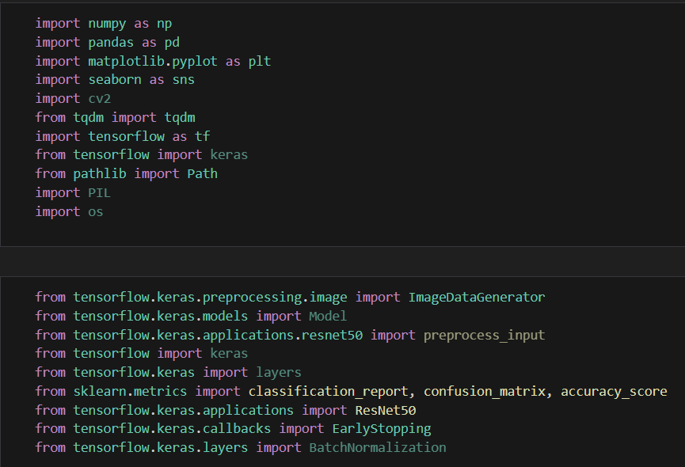

Load the images from the local directory:

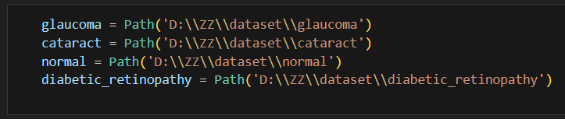

Create a pandas dataframe to store these:

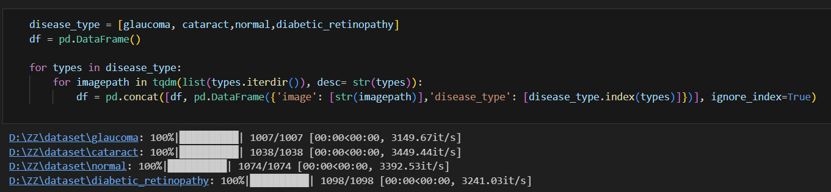

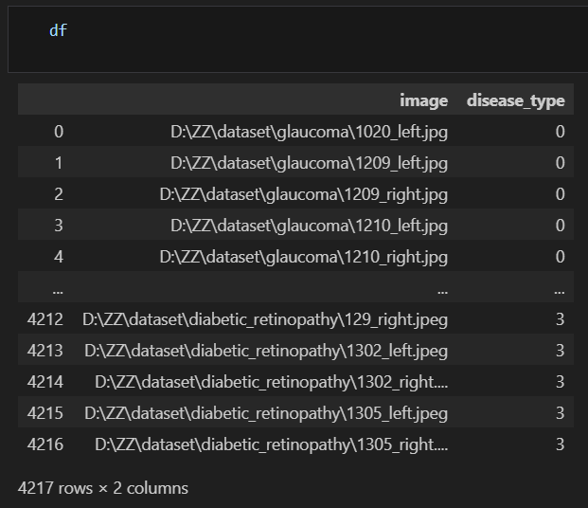

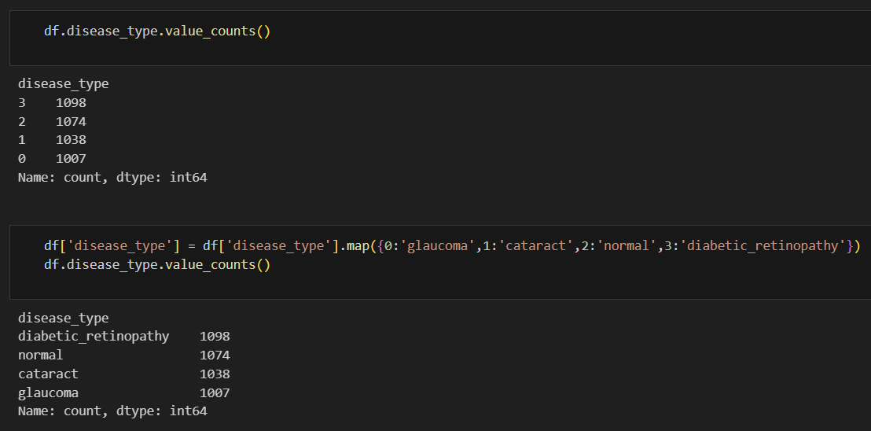

# Activity 2: Create training and testing dataset

To build a DL model we have to split training and testing data into two separate folders. But in this project we have already created a dataframe which we will divide into training and testing

Four different transfer learning models are used in our project and the best model (Resnet50) is selected. The image input size of Resnet50 model is 224, 224.

## Milestone 2: Image Preprocessing

### In this milestone we will be improving the image data that suppresses unwilling distortions or enhances some image features important for further processing, although perform some geometric transformations of images like rotation, scaling, translation, etc.

#### Activity 1: Configure ImageDataGenerator class

ImageDataGenerator class is instantiated and the configuration for the types of data augmentation There are five main types of data augmentation techniques for image data; specifically:

### Image shifts via the width_shift_range and height_shift_range arguments.

* + The image flips via the horizontal_flip and vertical_flip arguments.

### Image rotations via the rotation_range argument

* + Image brightness via the brightness_range argument.

### Image zoom via the zoom_range argument.

An instance of the ImageDataGenerator class can be constructed for train and test.

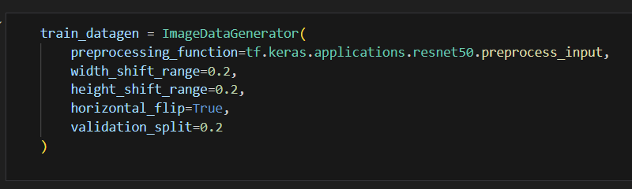

#### Activity 2: Apply ImageDataGenerator functionality to Train set and Test set

Let us apply ImageDataGenerator functionality to the Train set and Test set by using the following code. For Training set using flow_from_directory function.

This function will return batches of images from the subdirectories Arguments:

* + directory: Directory where the data is located. If labels are "inferred", it should contain subdirectories, each containing images for a class. Otherwise, the directory structure is ignored.
  + batch_size: Size of the batches of data which is 64.
  + target_size: Size to resize images after they are read from disk.
  + class_mode:
    - ‘int': means that the labels are encoded as integers (e.g. for sparse_categorical_crossentropy loss).
    - 'categorical' means that the labels are encoded as a categorical vector (e.g. for categorical_crossentropy loss).
    - 'binary' means that the labels (there can be only 2) are encoded as float32 scalars with values 0 or 1 (e.g. for binary_crossentropy).
    - None (no labels).

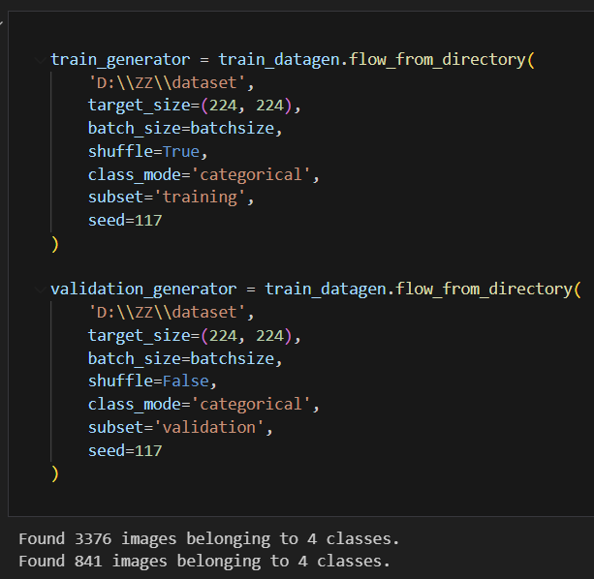

Total the dataset is having 3376 train images, 841 test images divided under 4 classes.

Milestone 3: Model Building

Now it's time to build our model. Let’s use the pre-trained model which is Resnet50, one of the convolution neural network (CNN) architecture which is considered as a very good model for Image classification.

Deep understanding on the Resnet50 model – Link is referred to in the prior knowledge section. Kindly refer to it before starting the model building part.

#### Activity 1: Pre-trained CNN model as a Feature Extractor

For one of the models, we will use it as a simple feature extractor by freezing all the five convolution blocks to make sure their weights don’t get updated after each epoch as we train our own model.

Here, we have considered images of dimension (224,224,3).

Also, we have assigned include_top = False because we are using convolution layer for features extraction and wants to train fully connected layer for our image classification (since it is not the part of Imagenet dataset)

Flatten layer flattens the input. Does not affect the batch size.

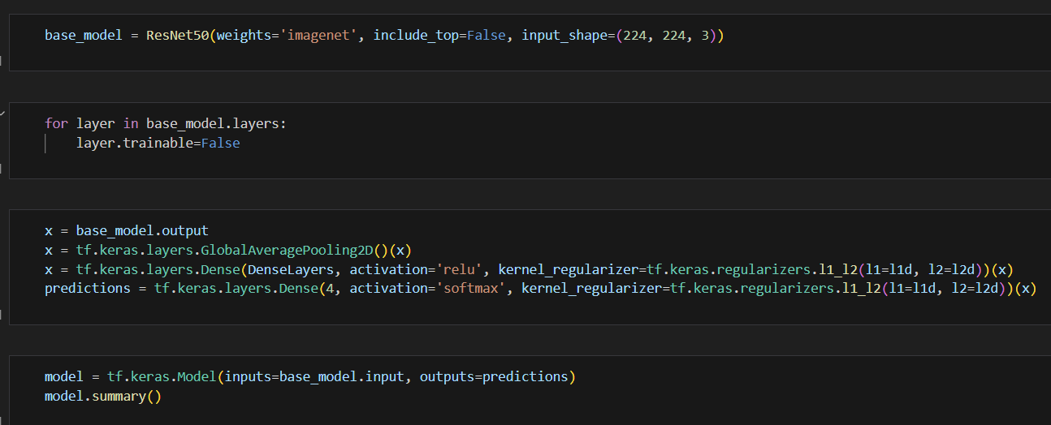

#### Activity 2: Adding Dense Layers

A dense layer is a deeply connected neural network layer. It is the most common and frequently used layer. Let us create a model object named model with inputs as VGG19.input and output as dense layer.

The number of neurons in the Dense layer is the same as the number of classes in the training set. The neurons in the last Dense layer, use softmax activation to convert their outputs into respective probabilities. Understanding the model is a very important phase to properly use it for training and prediction purposes.



Keras provides a simple method, summary to get the full information about the model and its layers.

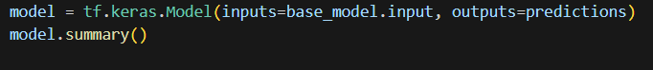

Model: "functional_1"

__________________________________________________________________________________________________

Layer (type) Output Shape Param # Connected to

==================================================================================================

input_1 (InputLayer) [(None, 224, 224, 3) 0

__________________________________________________________________________________________________

conv1_pad (ZeroPadding2D) (None, 230, 230, 3) 0 input_1[0][0]

__________________________________________________________________________________________________

conv1_conv (Conv2D) (None, 112, 112, 64) 9472 conv1_pad[0][0]

__________________________________________________________________________________________________

conv1_bn (BatchNormalization) (None, 112, 112, 64) 256 conv1_conv[0][0]

__________________________________________________________________________________________________

conv1_relu (Activation) (None, 112, 112, 64) 0 conv1_bn[0][0]

__________________________________________________________________________________________________

pool1_pad (ZeroPadding2D) (None, 114, 114, 64) 0 conv1_relu[0][0]

__________________________________________________________________________________________________

pool1_pool (MaxPooling2D) (None, 56, 56, 64) 0 pool1_pad[0][0]

__________________________________________________________________________________________________

conv2_block1_1_conv (Conv2D) (None, 56, 56, 64) 4160 pool1_pool[0][0]

__________________________________________________________________________________________________

conv2_block1_1_bn (BatchNormali (None, 56, 56, 64) 256 conv2_block1_1_conv[0][0]

__________________________________________________________________________________________________

conv2_block1_1_relu (Activation (None, 56, 56, 64) 0 conv2_block1_1_bn[0][0]

__________________________________________________________________________________________________

conv2_block1_2_conv (Conv2D) (None, 56, 56, 64) 36928 conv2_block1_1_relu[0][0]

__________________________________________________________________________________________________

conv2_block1_2_bn (BatchNormali (None, 56, 56, 64) 256 conv2_block1_2_conv[0][0]

__________________________________________________________________________________________________

conv2_block1_2_relu (Activation (None, 56, 56, 64) 0 conv2_block1_2_bn[0][0]

__________________________________________________________________________________________________

conv2_block1_0_conv (Conv2D) (None, 56, 56, 256) 16640 pool1_pool[0][0]

__________________________________________________________________________________________________

conv2_block1_3_conv (Conv2D) (None, 56, 56, 256) 16640 conv2_block1_2_relu[0][0]

__________________________________________________________________________________________________

conv2_block1_0_bn (BatchNormali (None, 56, 56, 256) 1024 conv2_block1_0_conv[0][0]

__________________________________________________________________________________________________

conv2_block1_3_bn (BatchNormali (None, 56, 56, 256) 1024 conv2_block1_3_conv[0][0]

__________________________________________________________________________________________________

conv2_block1_add (Add) (None, 56, 56, 256) 0 conv2_block1_0_bn[0][0]

conv2_block1_3_bn[0][0]

__________________________________________________________________________________________________

conv2_block1_out (Activation) (None, 56, 56, 256) 0 conv2_block1_add[0][0]

__________________________________________________________________________________________________

conv2_block2_1_conv (Conv2D) (None, 56, 56, 64) 16448 conv2_block1_out[0][0]

__________________________________________________________________________________________________

conv2_block2_1_bn (BatchNormali (None, 56, 56, 64) 256 conv2_block2_1_conv[0][0]

__________________________________________________________________________________________________

conv2_block2_1_relu (Activation (None, 56, 56, 64) 0 conv2_block2_1_bn[0][0]

__________________________________________________________________________________________________

conv2_block2_2_conv (Conv2D) (None, 56, 56, 64) 36928 conv2_block2_1_relu[0][0]

__________________________________________________________________________________________________

conv2_block2_2_bn (BatchNormali (None, 56, 56, 64) 256 conv2_block2_2_conv[0][0]

__________________________________________________________________________________________________

conv2_block2_2_relu (Activation (None, 56, 56, 64) 0 conv2_block2_2_bn[0][0]

__________________________________________________________________________________________________

conv2_block2_3_conv (Conv2D) (None, 56, 56, 256) 16640 conv2_block2_2_relu[0][0]

__________________________________________________________________________________________________

conv2_block2_3_bn (BatchNormali (None, 56, 56, 256) 1024 conv2_block2_3_conv[0][0]

__________________________________________________________________________________________________

conv2_block2_add (Add) (None, 56, 56, 256) 0 conv2_block1_out[0][0]

conv2_block2_3_bn[0][0]

__________________________________________________________________________________________________

conv2_block2_out (Activation) (None, 56, 56, 256) 0 conv2_block2_add[0][0]

__________________________________________________________________________________________________

conv2_block3_1_conv (Conv2D) (None, 56, 56, 64) 16448 conv2_block2_out[0][0]

__________________________________________________________________________________________________

conv2_block3_1_bn (BatchNormali (None, 56, 56, 64) 256 conv2_block3_1_conv[0][0]

__________________________________________________________________________________________________

conv2_block3_1_relu (Activation (None, 56, 56, 64) 0 conv2_block3_1_bn[0][0]

__________________________________________________________________________________________________

conv2_block3_2_conv (Conv2D) (None, 56, 56, 64) 36928 conv2_block3_1_relu[0][0]

__________________________________________________________________________________________________

conv2_block3_2_bn (BatchNormali (None, 56, 56, 64) 256 conv2_block3_2_conv[0][0]

__________________________________________________________________________________________________

conv2_block3_2_relu (Activation (None, 56, 56, 64) 0 conv2_block3_2_bn[0][0]

__________________________________________________________________________________________________

conv2_block3_3_conv (Conv2D) (None, 56, 56, 256) 16640 conv2_block3_2_relu[0][0]

__________________________________________________________________________________________________

conv2_block3_3_bn (BatchNormali (None, 56, 56, 256) 1024 conv2_block3_3_conv[0][0]

__________________________________________________________________________________________________

conv2_block3_add (Add) (None, 56, 56, 256) 0 conv2_block2_out[0][0]

conv2_block3_3_bn[0][0]

__________________________________________________________________________________________________

conv2_block3_out (Activation) (None, 56, 56, 256) 0 conv2_block3_add[0][0]

__________________________________________________________________________________________________

conv3_block1_1_conv (Conv2D) (None, 28, 28, 128) 32896 conv2_block3_out[0][0]

__________________________________________________________________________________________________

conv3_block1_1_bn (BatchNormali (None, 28, 28, 128) 512 conv3_block1_1_conv[0][0]

__________________________________________________________________________________________________

conv3_block1_1_relu (Activation (None, 28, 28, 128) 0 conv3_block1_1_bn[0][0]

__________________________________________________________________________________________________

conv3_block1_2_conv (Conv2D) (None, 28, 28, 128) 147584 conv3_block1_1_relu[0][0]

__________________________________________________________________________________________________

conv3_block1_2_bn (BatchNormali (None, 28, 28, 128) 512 conv3_block1_2_conv[0][0]

__________________________________________________________________________________________________

conv3_block1_2_relu (Activation (None, 28, 28, 128) 0 conv3_block1_2_bn[0][0]

__________________________________________________________________________________________________

conv3_block1_0_conv (Conv2D) (None, 28, 28, 512) 131584 conv2_block3_out[0][0]

__________________________________________________________________________________________________

conv3_block1_3_conv (Conv2D) (None, 28, 28, 512) 66048 conv3_block1_2_relu[0][0]

__________________________________________________________________________________________________

conv3_block1_0_bn (BatchNormali (None, 28, 28, 512) 2048 conv3_block1_0_conv[0][0]

__________________________________________________________________________________________________

conv3_block1_3_bn (BatchNormali (None, 28, 28, 512) 2048 conv3_block1_3_conv[0][0]

__________________________________________________________________________________________________

conv3_block1_add (Add) (None, 28, 28, 512) 0 conv3_block1_0_bn[0][0]

conv3_block1_3_bn[0][0]

__________________________________________________________________________________________________

conv3_block1_out (Activation) (None, 28, 28, 512) 0 conv3_block1_add[0][0]

__________________________________________________________________________________________________

conv3_block2_1_conv (Conv2D) (None, 28, 28, 128) 65664 conv3_block1_out[0][0]

__________________________________________________________________________________________________

conv3_block2_1_bn (BatchNormali (None, 28, 28, 128) 512 conv3_block2_1_conv[0][0]

__________________________________________________________________________________________________

conv3_block2_1_relu (Activation (None, 28, 28, 128) 0 conv3_block2_1_bn[0][0]

__________________________________________________________________________________________________

conv3_block2_2_conv (Conv2D) (None, 28, 28, 128) 147584 conv3_block2_1_relu[0][0]

__________________________________________________________________________________________________

conv3_block2_2_bn (BatchNormali (None, 28, 28, 128) 512 conv3_block2_2_conv[0][0]

__________________________________________________________________________________________________

conv3_block2_2_relu (Activation (None, 28, 28, 128) 0 conv3_block2_2_bn[0][0]

__________________________________________________________________________________________________

conv3_block2_3_conv (Conv2D) (None, 28, 28, 512) 66048 conv3_block2_2_relu[0][0]

__________________________________________________________________________________________________

conv3_block2_3_bn (BatchNormali (None, 28, 28, 512) 2048 conv3_block2_3_conv[0][0]

__________________________________________________________________________________________________

conv3_block2_add (Add) (None, 28, 28, 512) 0 conv3_block1_out[0][0]

conv3_block2_3_bn[0][0]

__________________________________________________________________________________________________

conv3_block2_out (Activation) (None, 28, 28, 512) 0 conv3_block2_add[0][0]

__________________________________________________________________________________________________

conv3_block3_1_conv (Conv2D) (None, 28, 28, 128) 65664 conv3_block2_out[0][0]

__________________________________________________________________________________________________

conv3_block3_1_bn (BatchNormali (None, 28, 28, 128) 512 conv3_block3_1_conv[0][0]

__________________________________________________________________________________________________

conv3_block3_1_relu (Activation (None, 28, 28, 128) 0 conv3_block3_1_bn[0][0]

__________________________________________________________________________________________________

conv3_block3_2_conv (Conv2D) (None, 28, 28, 128) 147584 conv3_block3_1_relu[0][0]

__________________________________________________________________________________________________

conv3_block3_2_bn (BatchNormali (None, 28, 28, 128) 512 conv3_block3_2_conv[0][0]

__________________________________________________________________________________________________

conv3_block3_2_relu (Activation (None, 28, 28, 128) 0 conv3_block3_2_bn[0][0]

__________________________________________________________________________________________________

conv3_block3_3_conv (Conv2D) (None, 28, 28, 512) 66048 conv3_block3_2_relu[0][0]

__________________________________________________________________________________________________

conv3_block3_3_bn (BatchNormali (None, 28, 28, 512) 2048 conv3_block3_3_conv[0][0]

__________________________________________________________________________________________________

conv3_block3_add (Add) (None, 28, 28, 512) 0 conv3_block2_out[0][0]

conv3_block3_3_bn[0][0]

__________________________________________________________________________________________________

conv3_block3_out (Activation) (None, 28, 28, 512) 0 conv3_block3_add[0][0]

__________________________________________________________________________________________________

conv3_block4_1_conv (Conv2D) (None, 28, 28, 128) 65664 conv3_block3_out[0][0]

__________________________________________________________________________________________________

conv3_block4_1_bn (BatchNormali (None, 28, 28, 128) 512 conv3_block4_1_conv[0][0]

__________________________________________________________________________________________________

conv3_block4_1_relu (Activation (None, 28, 28, 128) 0 conv3_block4_1_bn[0][0]

__________________________________________________________________________________________________

conv3_block4_2_conv (Conv2D) (None, 28, 28, 128) 147584 conv3_block4_1_relu[0][0]

__________________________________________________________________________________________________

conv3_block4_2_bn (BatchNormali (None, 28, 28, 128) 512 conv3_block4_2_conv[0][0]

__________________________________________________________________________________________________

conv3_block4_2_relu (Activation (None, 28, 28, 128) 0 conv3_block4_2_bn[0][0]

__________________________________________________________________________________________________

conv3_block4_3_conv (Conv2D) (None, 28, 28, 512) 66048 conv3_block4_2_relu[0][0]

__________________________________________________________________________________________________

conv3_block4_3_bn (BatchNormali (None, 28, 28, 512) 2048 conv3_block4_3_conv[0][0]

__________________________________________________________________________________________________

conv3_block4_add (Add) (None, 28, 28, 512) 0 conv3_block3_out[0][0]

conv3_block4_3_bn[0][0]

__________________________________________________________________________________________________

conv3_block4_out (Activation) (None, 28, 28, 512) 0 conv3_block4_add[0][0]

__________________________________________________________________________________________________

conv4_block1_1_conv (Conv2D) (None, 14, 14, 256) 131328 conv3_block4_out[0][0]

__________________________________________________________________________________________________

conv4_block1_1_bn (BatchNormali (None, 14, 14, 256) 1024 conv4_block1_1_conv[0][0]

__________________________________________________________________________________________________

conv4_block1_1_relu (Activation (None, 14, 14, 256) 0 conv4_block1_1_bn[0][0]

__________________________________________________________________________________________________

conv4_block1_2_conv (Conv2D) (None, 14, 14, 256) 590080 conv4_block1_1_relu[0][0]

__________________________________________________________________________________________________

conv4_block1_2_bn (BatchNormali (None, 14, 14, 256) 1024 conv4_block1_2_conv[0][0]

__________________________________________________________________________________________________

conv4_block1_2_relu (Activation (None, 14, 14, 256) 0 conv4_block1_2_bn[0][0]

__________________________________________________________________________________________________

conv4_block1_0_conv (Conv2D) (None, 14, 14, 1024) 525312 conv3_block4_out[0][0]

__________________________________________________________________________________________________

conv4_block1_3_conv (Conv2D) (None, 14, 14, 1024) 263168 conv4_block1_2_relu[0][0]

__________________________________________________________________________________________________

conv4_block1_0_bn (BatchNormali (None, 14, 14, 1024) 4096 conv4_block1_0_conv[0][0]

__________________________________________________________________________________________________

conv4_block1_3_bn (BatchNormali (None, 14, 14, 1024) 4096 conv4_block1_3_conv[0][0]

__________________________________________________________________________________________________

conv4_block1_add (Add) (None, 14, 14, 1024) 0 conv4_block1_0_bn[0][0]

conv4_block1_3_bn[0][0]

__________________________________________________________________________________________________

conv4_block1_out (Activation) (None, 14, 14, 1024) 0 conv4_block1_add[0][0]

__________________________________________________________________________________________________

conv4_block2_1_conv (Conv2D) (None, 14, 14, 256) 262400 conv4_block1_out[0][0]

__________________________________________________________________________________________________

conv4_block2_1_bn (BatchNormali (None, 14, 14, 256) 1024 conv4_block2_1_conv[0][0]

__________________________________________________________________________________________________

conv4_block2_1_relu (Activation (None, 14, 14, 256) 0 conv4_block2_1_bn[0][0]

__________________________________________________________________________________________________

conv4_block2_2_conv (Conv2D) (None, 14, 14, 256) 590080 conv4_block2_1_relu[0][0]

__________________________________________________________________________________________________

conv4_block2_2_bn (BatchNormali (None, 14, 14, 256) 1024 conv4_block2_2_conv[0][0]

__________________________________________________________________________________________________

conv4_block2_2_relu (Activation (None, 14, 14, 256) 0 conv4_block2_2_bn[0][0]

__________________________________________________________________________________________________

conv4_block2_3_conv (Conv2D) (None, 14, 14, 1024) 263168 conv4_block2_2_relu[0][0]

__________________________________________________________________________________________________

conv4_block2_3_bn (BatchNormali (None, 14, 14, 1024) 4096 conv4_block2_3_conv[0][0]

__________________________________________________________________________________________________

conv4_block2_add (Add) (None, 14, 14, 1024) 0 conv4_block1_out[0][0]

conv4_block2_3_bn[0][0]

__________________________________________________________________________________________________

conv4_block2_out (Activation) (None, 14, 14, 1024) 0 conv4_block2_add[0][0]

__________________________________________________________________________________________________

conv4_block3_1_conv (Conv2D) (None, 14, 14, 256) 262400 conv4_block2_out[0][0]

__________________________________________________________________________________________________

conv4_block3_1_bn (BatchNormali (None, 14, 14, 256) 1024 conv4_block3_1_conv[0][0]

__________________________________________________________________________________________________

conv4_block3_1_relu (Activation (None, 14, 14, 256) 0 conv4_block3_1_bn[0][0]

__________________________________________________________________________________________________

conv4_block3_2_conv (Conv2D) (None, 14, 14, 256) 590080 conv4_block3_1_relu[0][0]

__________________________________________________________________________________________________

conv4_block3_2_bn (BatchNormali (None, 14, 14, 256) 1024 conv4_block3_2_conv[0][0]

__________________________________________________________________________________________________

conv4_block3_2_relu (Activation (None, 14, 14, 256) 0 conv4_block3_2_bn[0][0]

__________________________________________________________________________________________________

conv4_block3_3_conv (Conv2D) (None, 14, 14, 1024) 263168 conv4_block3_2_relu[0][0]

__________________________________________________________________________________________________

conv4_block3_3_bn (BatchNormali (None, 14, 14, 1024) 4096 conv4_block3_3_conv[0][0]

__________________________________________________________________________________________________

conv4_block3_add (Add) (None, 14, 14, 1024) 0 conv4_block2_out[0][0]

conv4_block3_3_bn[0][0]

__________________________________________________________________________________________________

conv4_block3_out (Activation) (None, 14, 14, 1024) 0 conv4_block3_add[0][0]

__________________________________________________________________________________________________

conv4_block4_1_conv (Conv2D) (None, 14, 14, 256) 262400 conv4_block3_out[0][0]

__________________________________________________________________________________________________

conv4_block4_1_bn (BatchNormali (None, 14, 14, 256) 1024 conv4_block4_1_conv[0][0]

__________________________________________________________________________________________________

conv4_block4_1_relu (Activation (None, 14, 14, 256) 0 conv4_block4_1_bn[0][0]

__________________________________________________________________________________________________

conv4_block4_2_conv (Conv2D) (None, 14, 14, 256) 590080 conv4_block4_1_relu[0][0]

__________________________________________________________________________________________________

conv4_block4_2_bn (BatchNormali (None, 14, 14, 256) 1024 conv4_block4_2_conv[0][0]

__________________________________________________________________________________________________

conv4_block4_2_relu (Activation (None, 14, 14, 256) 0 conv4_block4_2_bn[0][0]

__________________________________________________________________________________________________

conv4_block4_3_conv (Conv2D) (None, 14, 14, 1024) 263168 conv4_block4_2_relu[0][0]

__________________________________________________________________________________________________

conv4_block4_3_bn (BatchNormali (None, 14, 14, 1024) 4096 conv4_block4_3_conv[0][0]

__________________________________________________________________________________________________

conv4_block4_add (Add) (None, 14, 14, 1024) 0 conv4_block3_out[0][0]

conv4_block4_3_bn[0][0]

__________________________________________________________________________________________________

conv4_block4_out (Activation) (None, 14, 14, 1024) 0 conv4_block4_add[0][0]

__________________________________________________________________________________________________

conv4_block5_1_conv (Conv2D) (None, 14, 14, 256) 262400 conv4_block4_out[0][0]

__________________________________________________________________________________________________

conv4_block5_1_bn (BatchNormali (None, 14, 14, 256) 1024 conv4_block5_1_conv[0][0]

__________________________________________________________________________________________________

conv4_block5_1_relu (Activation (None, 14, 14, 256) 0 conv4_block5_1_bn[0][0]

__________________________________________________________________________________________________

conv4_block5_2_conv (Conv2D) (None, 14, 14, 256) 590080 conv4_block5_1_relu[0][0]

__________________________________________________________________________________________________

conv4_block5_2_bn (BatchNormali (None, 14, 14, 256) 1024 conv4_block5_2_conv[0][0]

__________________________________________________________________________________________________

conv4_block5_2_relu (Activation (None, 14, 14, 256) 0 conv4_block5_2_bn[0][0]

__________________________________________________________________________________________________

conv4_block5_3_conv (Conv2D) (None, 14, 14, 1024) 263168 conv4_block5_2_relu[0][0]

__________________________________________________________________________________________________

conv4_block5_3_bn (BatchNormali (None, 14, 14, 1024) 4096 conv4_block5_3_conv[0][0]

__________________________________________________________________________________________________

conv4_block5_add (Add) (None, 14, 14, 1024) 0 conv4_block4_out[0][0]

conv4_block5_3_bn[0][0]

__________________________________________________________________________________________________

conv4_block5_out (Activation) (None, 14, 14, 1024) 0 conv4_block5_add[0][0]

__________________________________________________________________________________________________

conv4_block6_1_conv (Conv2D) (None, 14, 14, 256) 262400 conv4_block5_out[0][0]

__________________________________________________________________________________________________

conv4_block6_1_bn (BatchNormali (None, 14, 14, 256) 1024 conv4_block6_1_conv[0][0]

__________________________________________________________________________________________________

conv4_block6_1_relu (Activation (None, 14, 14, 256) 0 conv4_block6_1_bn[0][0]

__________________________________________________________________________________________________

conv4_block6_2_conv (Conv2D) (None, 14, 14, 256) 590080 conv4_block6_1_relu[0][0]

__________________________________________________________________________________________________

conv4_block6_2_bn (BatchNormali (None, 14, 14, 256) 1024 conv4_block6_2_conv[0][0]

__________________________________________________________________________________________________

conv4_block6_2_relu (Activation (None, 14, 14, 256) 0 conv4_block6_2_bn[0][0]

__________________________________________________________________________________________________

conv4_block6_3_conv (Conv2D) (None, 14, 14, 1024) 263168 conv4_block6_2_relu[0][0]

__________________________________________________________________________________________________

conv4_block6_3_bn (BatchNormali (None, 14, 14, 1024) 4096 conv4_block6_3_conv[0][0]

__________________________________________________________________________________________________

conv4_block6_add (Add) (None, 14, 14, 1024) 0 conv4_block5_out[0][0]

conv4_block6_3_bn[0][0]

__________________________________________________________________________________________________

conv4_block6_out (Activation) (None, 14, 14, 1024) 0 conv4_block6_add[0][0]

__________________________________________________________________________________________________

conv5_block1_1_conv (Conv2D) (None, 7, 7, 512) 524800 conv4_block6_out[0][0]

__________________________________________________________________________________________________

conv5_block1_1_bn (BatchNormali (None, 7, 7, 512) 2048 conv5_block1_1_conv[0][0]

__________________________________________________________________________________________________

conv5_block1_1_relu (Activation (None, 7, 7, 512) 0 conv5_block1_1_bn[0][0]

__________________________________________________________________________________________________

conv5_block1_2_conv (Conv2D) (None, 7, 7, 512) 2359808 conv5_block1_1_relu[0][0]

__________________________________________________________________________________________________

conv5_block1_2_bn (BatchNormali (None, 7, 7, 512) 2048 conv5_block1_2_conv[0][0]

__________________________________________________________________________________________________

conv5_block1_2_relu (Activation (None, 7, 7, 512) 0 conv5_block1_2_bn[0][0]

__________________________________________________________________________________________________

conv5_block1_0_conv (Conv2D) (None, 7, 7, 2048) 2099200 conv4_block6_out[0][0]

__________________________________________________________________________________________________

conv5_block1_3_conv (Conv2D) (None, 7, 7, 2048) 1050624 conv5_block1_2_relu[0][0]

__________________________________________________________________________________________________

conv5_block1_0_bn (BatchNormali (None, 7, 7, 2048) 8192 conv5_block1_0_conv[0][0]

__________________________________________________________________________________________________

conv5_block1_3_bn (BatchNormali (None, 7, 7, 2048) 8192 conv5_block1_3_conv[0][0]

__________________________________________________________________________________________________

conv5_block1_add (Add) (None, 7, 7, 2048) 0 conv5_block1_0_bn[0][0]

conv5_block1_3_bn[0][0]

__________________________________________________________________________________________________

conv5_block1_out (Activation) (None, 7, 7, 2048) 0 conv5_block1_add[0][0]

__________________________________________________________________________________________________

conv5_block2_1_conv (Conv2D) (None, 7, 7, 512) 1049088 conv5_block1_out[0][0]

__________________________________________________________________________________________________

conv5_block2_1_bn (BatchNormali (None, 7, 7, 512) 2048 conv5_block2_1_conv[0][0]

__________________________________________________________________________________________________

conv5_block2_1_relu (Activation (None, 7, 7, 512) 0 conv5_block2_1_bn[0][0]

__________________________________________________________________________________________________

conv5_block2_2_conv (Conv2D) (None, 7, 7, 512) 2359808 conv5_block2_1_relu[0][0]

__________________________________________________________________________________________________

conv5_block2_2_bn (BatchNormali (None, 7, 7, 512) 2048 conv5_block2_2_conv[0][0]

__________________________________________________________________________________________________

conv5_block2_2_relu (Activation (None, 7, 7, 512) 0 conv5_block2_2_bn[0][0]

__________________________________________________________________________________________________

conv5_block2_3_conv (Conv2D) (None, 7, 7, 2048) 1050624 conv5_block2_2_relu[0][0]

__________________________________________________________________________________________________

conv5_block2_3_bn (BatchNormali (None, 7, 7, 2048) 8192 conv5_block2_3_conv[0][0]

__________________________________________________________________________________________________

conv5_block2_add (Add) (None, 7, 7, 2048) 0 conv5_block1_out[0][0]

conv5_block2_3_bn[0][0]

__________________________________________________________________________________________________

conv5_block2_out (Activation) (None, 7, 7, 2048) 0 conv5_block2_add[0][0]

__________________________________________________________________________________________________

conv5_block3_1_conv (Conv2D) (None, 7, 7, 512) 1049088 conv5_block2_out[0][0]

__________________________________________________________________________________________________

conv5_block3_1_bn (BatchNormali (None, 7, 7, 512) 2048 conv5_block3_1_conv[0][0]

__________________________________________________________________________________________________

conv5_block3_1_relu (Activation (None, 7, 7, 512) 0 conv5_block3_1_bn[0][0]

__________________________________________________________________________________________________

conv5_block3_2_conv (Conv2D) (None, 7, 7, 512) 2359808 conv5_block3_1_relu[0][0]

__________________________________________________________________________________________________

conv5_block3_2_bn (BatchNormali (None, 7, 7, 512) 2048 conv5_block3_2_conv[0][0]

__________________________________________________________________________________________________

conv5_block3_2_relu (Activation (None, 7, 7, 512) 0 conv5_block3_2_bn[0][0]

__________________________________________________________________________________________________

conv5_block3_3_conv (Conv2D) (None, 7, 7, 2048) 1050624 conv5_block3_2_relu[0][0]

__________________________________________________________________________________________________

conv5_block3_3_bn (BatchNormali (None, 7, 7, 2048) 8192 conv5_block3_3_conv[0][0]

__________________________________________________________________________________________________

conv5_block3_add (Add) (None, 7, 7, 2048) 0 conv5_block2_out[0][0]

conv5_block3_3_bn[0][0]

__________________________________________________________________________________________________

conv5_block3_out (Activation) (None, 7, 7, 2048) 0 conv5_block3_add[0][0]

__________________________________________________________________________________________________

global_average_pooling2d (Globa (None, 2048) 0 conv5_block3_out[0][0]

__________________________________________________________________________________________________

dense (Dense) (None, 1024) 2098176 global_average_pooling2d[0][0]

__________________________________________________________________________________________________

dense_1 (Dense) (None, 4) 4100 dense[0][0]

==================================================================================================

Total params: 25,689,988

Trainable params: 25,636,868

Non-trainable params: 53,120

__________________________________________________________________________________________________

#### Activity 3: Configure the Learning Process

The compilation is the final step in creating a model. Once the compilation is done, we can move on to the training phase. The loss function is used to find errors or deviations in the learning process. Keras requires a loss function during the model compilation process.

Optimization is an important process that optimizes the input weights by comparing the prediction and the loss function. Here we are using Nadam optimizer

Metrics are used to evaluate the performance of your model. It is similar to the loss function, but not used in the training process



#### Activity 4: Train the model

Now, let us train our model with our image dataset. The model is trained for 50 epochs and after every epoch, the current model state is saved if the model has the least loss encountered till that time. We can see that the training loss decreases in almost every epoch and probably there is further scope to improve the model.

**.fit** functions used to train a deep learning neural network

#### Arguments:

* + steps_per_epoch: it specifies the total number of steps taken from the generator as soon as one epoch is finished and the next epoch has started. We can calculate the value of steps_per_epoch as the total number of samples in your dataset divided by the batch size.
  + Epochs: an integer and number of epochs we want to train our model for.
  + validation_data can be either:
    - an inputs and targets list
    - a generator
    - an inputs, targets, and sample_weights list which can be used to evaluate the loss and metrics for any model after any epoch has ended.
  + validation_steps: only if the validation_data is a generator then only this argument can be used. It specifies the total number of steps taken from the generator before it is stopped at every epoch and its value is calculated as the total number of validation data points in your dataset divided by the validation batch size.



Epoch 1/50

844/844 [==============================] - 136s 161ms/step - loss: 5.0985 - accuracy: 0.7906 - val_loss: 5.0733 - val_accuracy: 0.7229

Epoch 2/50

844/844 [==============================] - 130s 154ms/step - loss: 4.4178 - accuracy: 0.8943 - val_loss: 4.3493 - val_accuracy: 0.7990

Epoch 3/50

844/844 [==============================] - 129s 153ms/step - loss: 3.8862 - accuracy: 0.9159 - val_loss: 3.9598 - val_accuracy: 0.7895

Epoch 4/50

844/844 [==============================] - 129s 153ms/step - loss: 3.3344 - accuracy: 0.9292 - val_loss: 3.5462 - val_accuracy: 0.7776

Epoch 5/50

844/844 [==============================] - 129s 153ms/step - loss: 2.8280 - accuracy: 0.9313 - val_loss: 3.2302 - val_accuracy: 0.7134

Epoch 6/50

844/844 [==============================] - 129s 153ms/step - loss: 2.3193 - accuracy: 0.9416 - val_loss: 2.7757 - val_accuracy: 0.7194

Epoch 7/50

844/844 [==============================] - 130s 154ms/step - loss: 1.8715 - accuracy: 0.9514 - val_loss: 2.0902 - val_accuracy: 0.8002

Epoch 8/50

844/844 [==============================] - 130s 154ms/step - loss: 1.5026 - accuracy: 0.9491 - val_loss: 1.6410 - val_accuracy: 0.8359

Epoch 9/50

844/844 [==============================] - 129s 153ms/step - loss: 1.1769 - accuracy: 0.9573 - val_loss: 1.5302 - val_accuracy: 0.8086

Epoch 10/50

844/844 [==============================] - 130s 154ms/step - loss: 0.9303 - accuracy: 0.9609 - val_loss: 1.4376 - val_accuracy: 0.7907

Epoch 11/50

844/844 [==============================] - 130s 154ms/step - loss: 0.7576 - accuracy: 0.9565 - val_loss: 1.0930 - val_accuracy: 0.8335

Epoch 12/50

844/844 [==============================] - 130s 154ms/step - loss: 0.6123 - accuracy: 0.9630 - val_loss: 1.1002 - val_accuracy: 0.8121

Epoch 13/50

844/844 [==============================] - 130s 153ms/step - loss: 0.5018 - accuracy: 0.9659 - val_loss: 1.0062 - val_accuracy: 0.7955

Epoch 14/50

844/844 [==============================] - 129s 153ms/step - loss: 0.4094 - accuracy: 0.9692 - val_loss: 0.8090 - val_accuracy: 0.8502

Epoch 15/50

844/844 [==============================] - 128s 152ms/step - loss: 0.3517 - accuracy: 0.9686 - val_loss: 1.1023 - val_accuracy: 0.7741

Epoch 16/50

844/844 [==============================] - 129s 152ms/step - loss: 0.2939 - accuracy: 0.9730 - val_loss: 0.6889 - val_accuracy: 0.8585

Epoch 17/50

844/844 [==============================] - 128s 152ms/step - loss: 0.2469 - accuracy: 0.9790 - val_loss: 0.9432 - val_accuracy: 0.7990

Epoch 18/50

844/844 [==============================] - 129s 152ms/step - loss: 0.2230 - accuracy: 0.9772 - val_loss: 0.6865 - val_accuracy: 0.8335

Epoch 19/50

844/844 [==============================] - 129s 153ms/step - loss: 0.1990 - accuracy: 0.9757 - val_loss: 0.6426 - val_accuracy: 0.8526

Epoch 20/50

844/844 [==============================] - 128s 152ms/step - loss: 0.1861 - accuracy: 0.9736 - val_loss: 0.5793 - val_accuracy: 0.8549

Epoch 21/50

844/844 [==============================] - 129s 153ms/step - loss: 0.1769 - accuracy: 0.9816 - val_loss: 0.7750 - val_accuracy: 0.8002

Epoch 22/50

844/844 [==============================] - 128s 152ms/step - loss: 0.1593 - accuracy: 0.9790 - val_loss: 0.8275 - val_accuracy: 0.8098

Epoch 23/50

844/844 [==============================] - 129s 152ms/step - loss: 0.1337 - accuracy: 0.9843 - val_loss: 0.9695 - val_accuracy: 0.7907

Epoch 24/50

844/844 [==============================] - 129s 152ms/step - loss: 0.1304 - accuracy: 0.9819 - val_loss: 0.6045 - val_accuracy: 0.8442

Epoch 25/50

844/844 [==============================] - 129s 153ms/step - loss: 0.1332 - accuracy: 0.9816 - val_loss: 0.6142 - val_accuracy: 0.8419

Epoch 26/50

844/844 [==============================] - 129s 153ms/step - loss: 0.1010 - accuracy: 0.9899 - val_loss: 0.5711 - val_accuracy: 0.8514

Epoch 27/50

844/844 [==============================] - 132s 156ms/step - loss: 0.1152 - accuracy: 0.9837 - val_loss: 0.7877 - val_accuracy: 0.8300

Epoch 28/50

844/844 [==============================] - 131s 155ms/step - loss: 0.1011 - accuracy: 0.9884 - val_loss: 0.9439 - val_accuracy: 0.7955

Epoch 29/50

844/844 [==============================] - 131s 155ms/step - loss: 0.1083 - accuracy: 0.9837 - val_loss: 0.4959 - val_accuracy: 0.8728

Epoch 30/50

844/844 [==============================] - 130s 154ms/step - loss: 0.1025 - accuracy: 0.9846 - val_loss: 0.6658 - val_accuracy: 0.8407

Epoch 31/50

844/844 [==============================] - 130s 154ms/step - loss: 0.0894 - accuracy: 0.9890 - val_loss: 0.7271 - val_accuracy: 0.8288

Epoch 32/50

844/844 [==============================] - 130s 154ms/step - loss: 0.1005 - accuracy: 0.9834 - val_loss: 0.7241 - val_accuracy: 0.8228

Epoch 33/50

844/844 [==============================] - 131s 155ms/step - loss: 0.0782 - accuracy: 0.9911 - val_loss: 0.6404 - val_accuracy: 0.8157

Epoch 34/50

844/844 [==============================] - 131s 155ms/step - loss: 0.0832 - accuracy: 0.9884 - val_loss: 0.8633 - val_accuracy: 0.7860

Epoch 35/50

844/844 [==============================] - 131s 155ms/step - loss: 0.0824 - accuracy: 0.9879 - val_loss: 1.9445 - val_accuracy: 0.5470

Epoch 36/50

844/844 [==============================] - 131s 155ms/step - loss: 0.0837 - accuracy: 0.9870 - val_loss: 0.5923 - val_accuracy: 0.8490

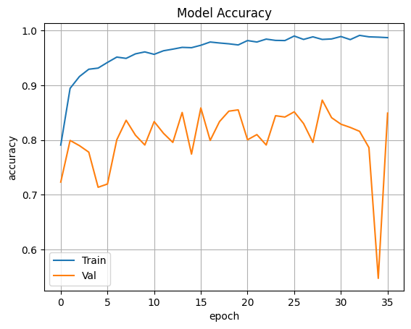

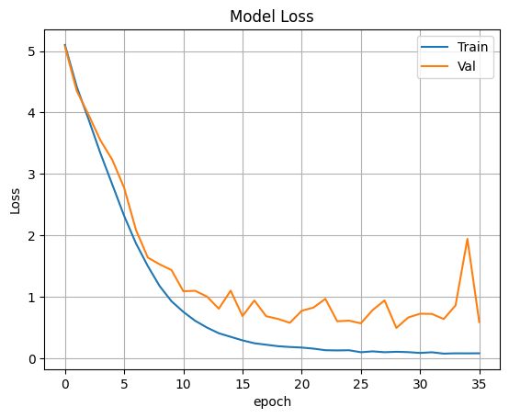

# Activity 5: Save the Model

Out of all the models we tried (CNN, VGG19, Resnet50 V2, Inception V3 & Xception) VGG19 gave us the best accuracy.



So we are saving VGG19 as our final mode

The model is saved with .h5 extension as follows

An H5 file is a data file saved in the Hierarchical Data Format (HDF). It contains multidimensional arrays of scientific data.

**Testing the model:**

Evaluation is a process during the development of the model to check whether the model is the best fit for the given problem and corresponding data. Load the saved model using load_model.

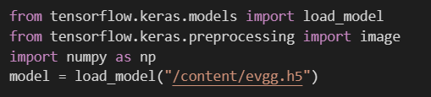

### Taking an image as input and checking the results

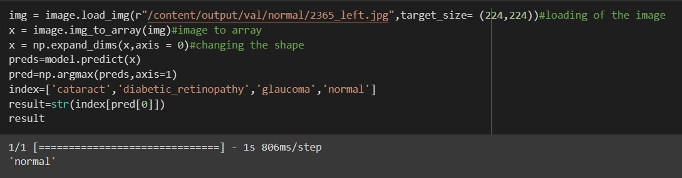

So our model has predicted the label correctly as Nomal.

**Milestone 4: Application Building**

In this section, we will be building a web application that is integrated to the model we built. A UI is provided for the uses where he has to enter the values for predictions. The enter values are given to the saved model and prediction is showcased on the UI.

This section has the following tasks

* + Creating JS Pages in React
  + Writing JS code using Tensorflow JS
  + Run the application

#### Activity1: Building React Pages:

LANDING PAGE:



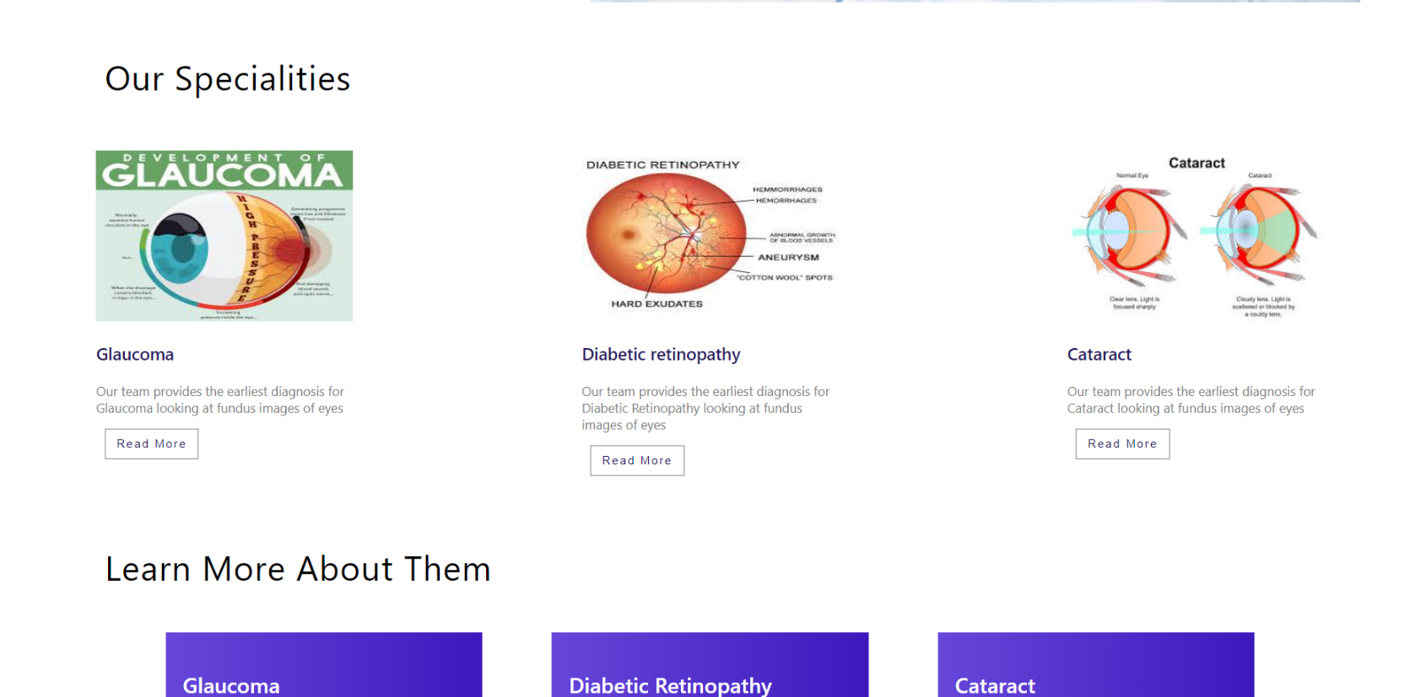

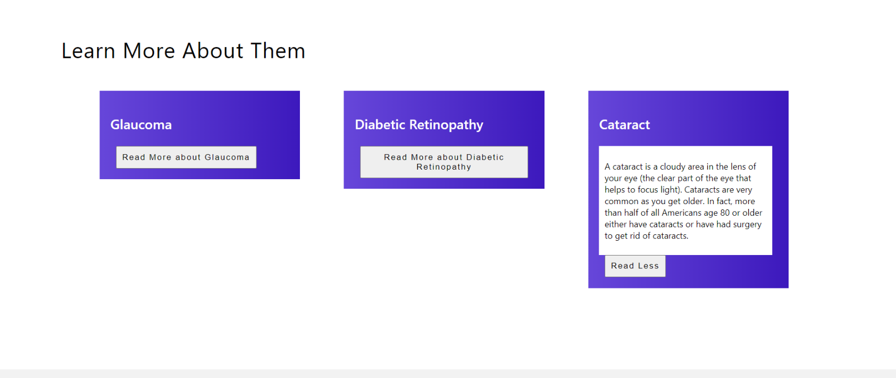

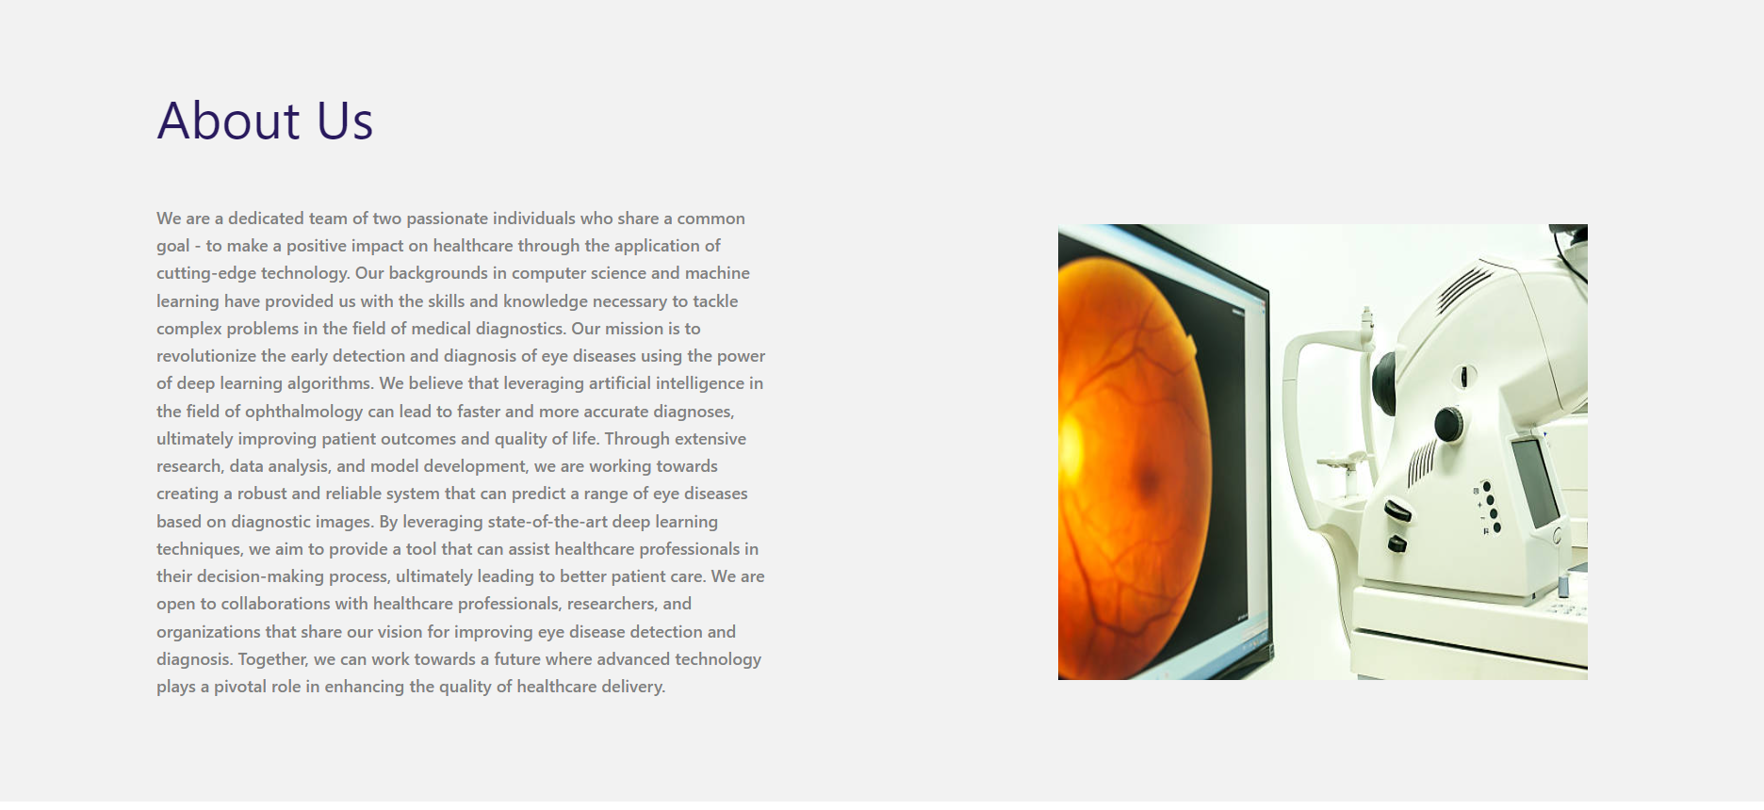



SIGN UP PAGE:

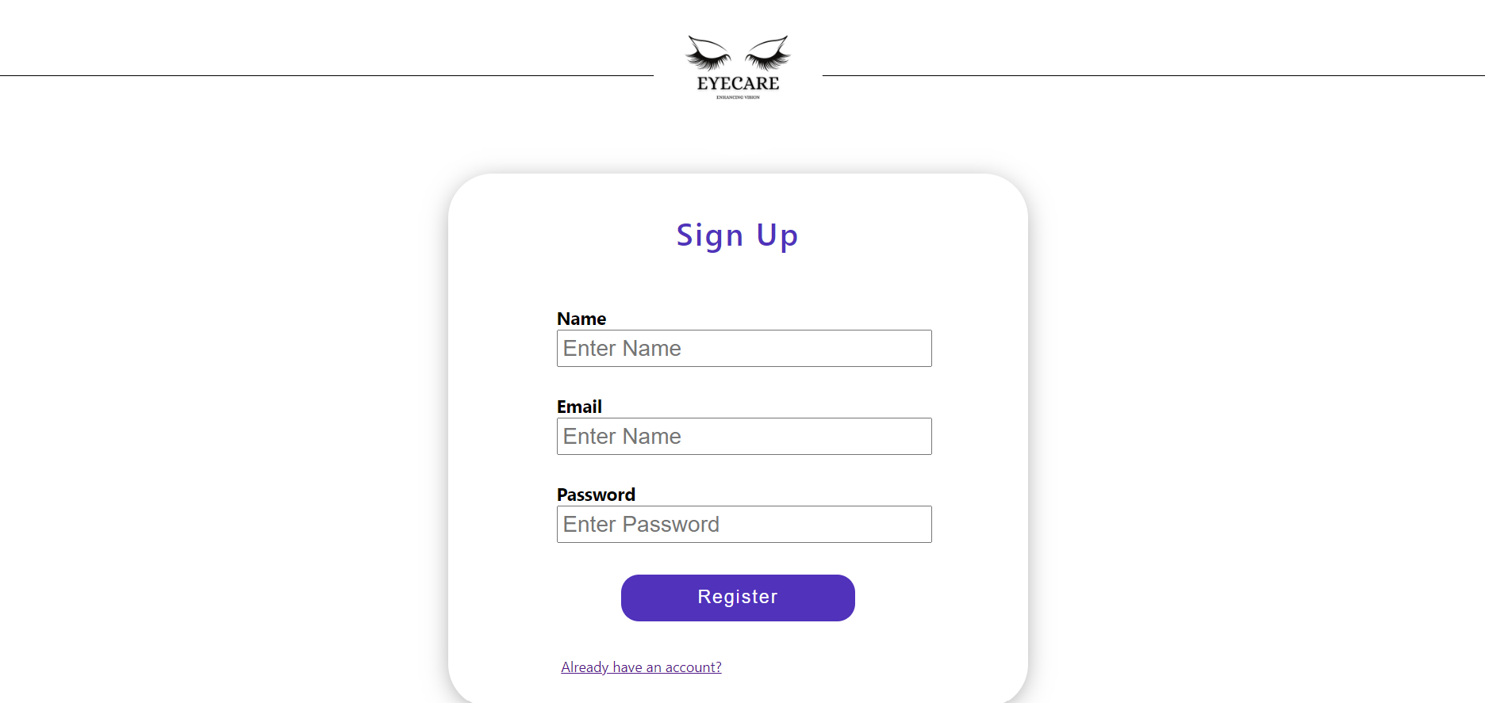

LOGIN PAGE:

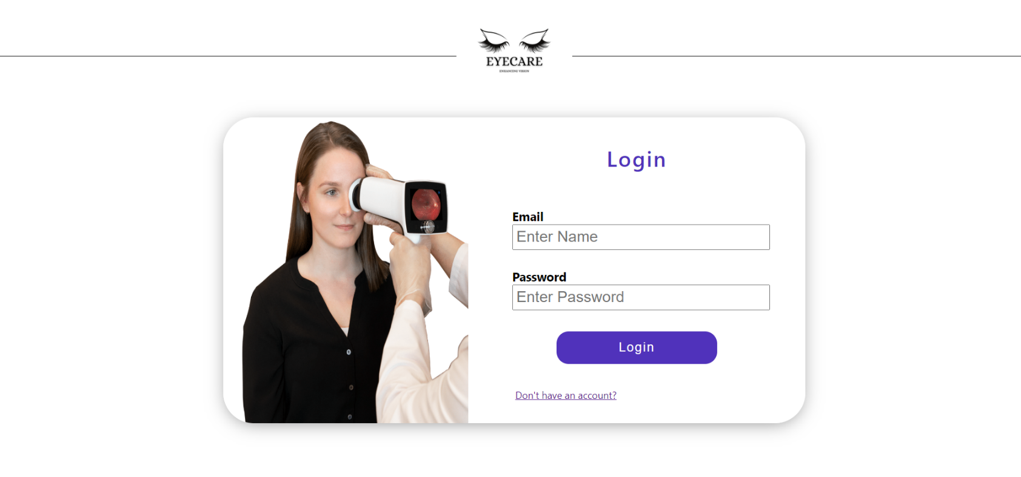

HOME PAGE (AFTER LOGIN):

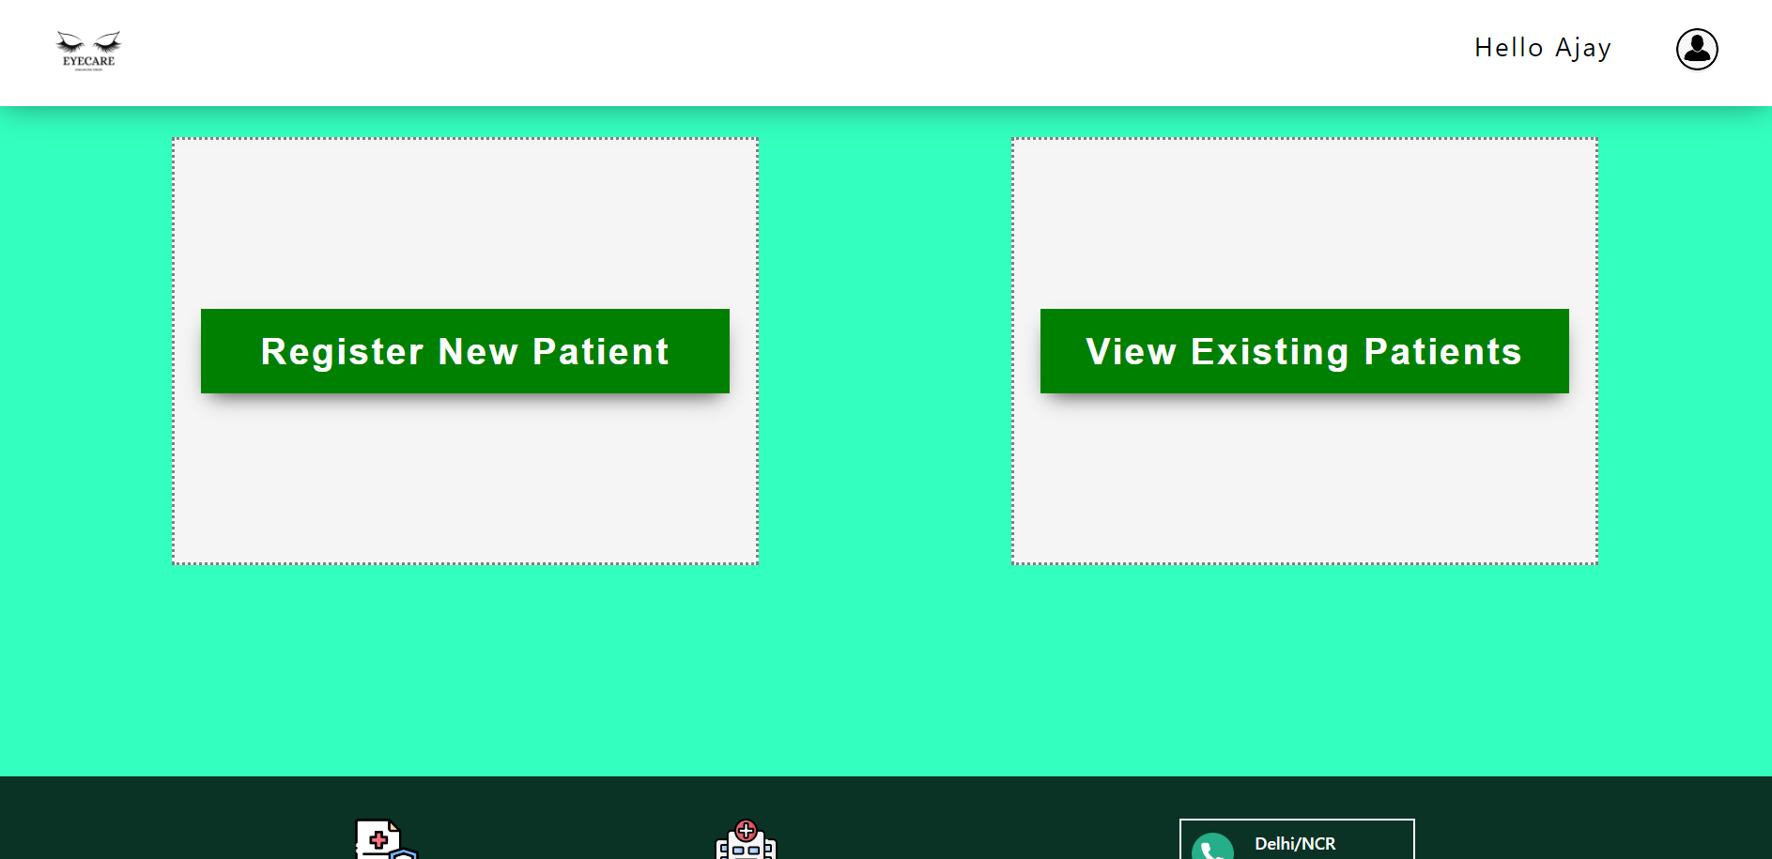

REGISTER NEW PATIENT PAGE:



VIEW EXISTING PATIENTS PAGE (PATIENTS RECORDS ) :

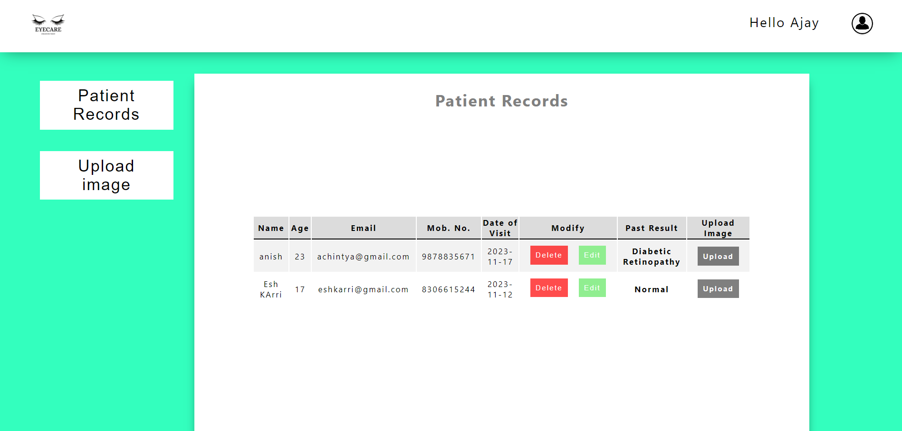

UPLOAD IMAGE PAGE:

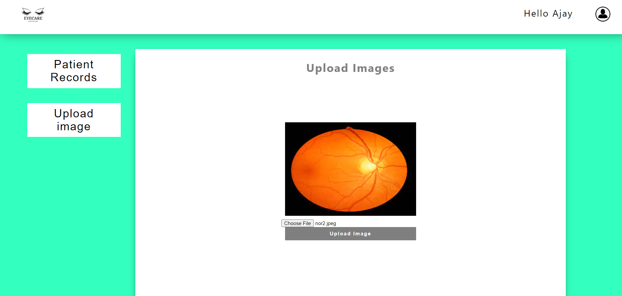

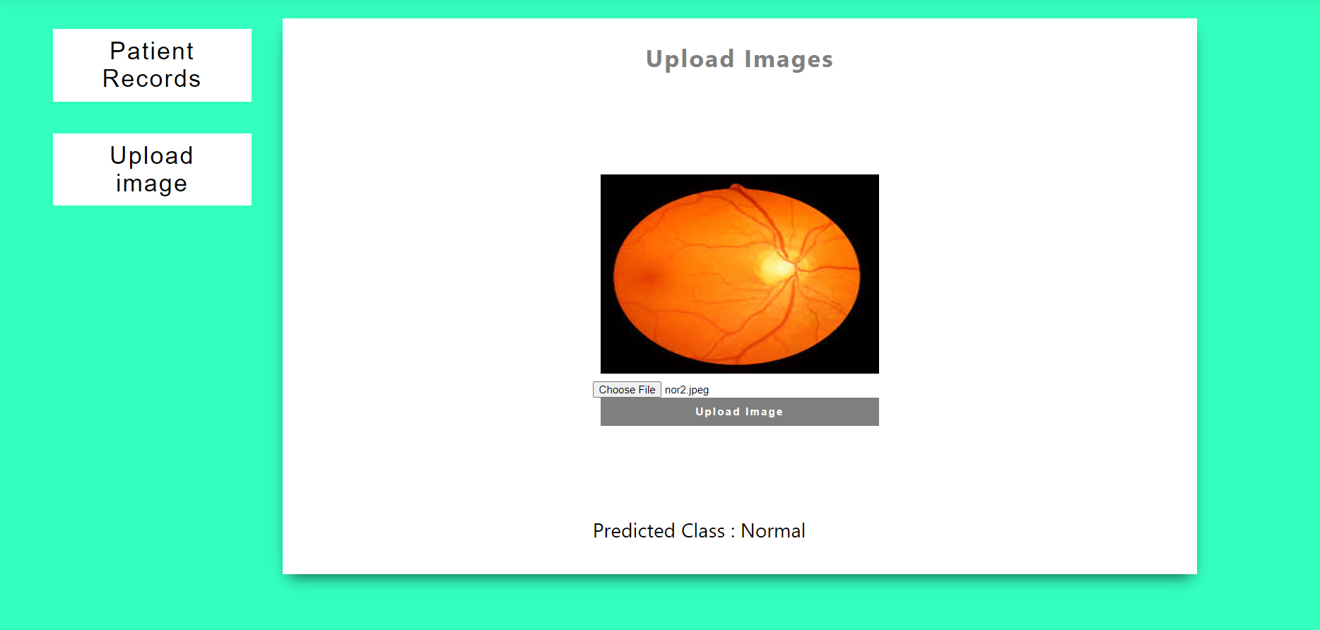

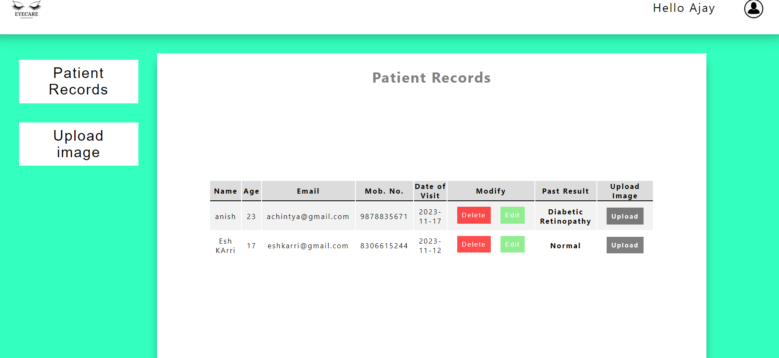

#### Activity 2: Write JS CODE:

#### ALL THE COMPONENTS

A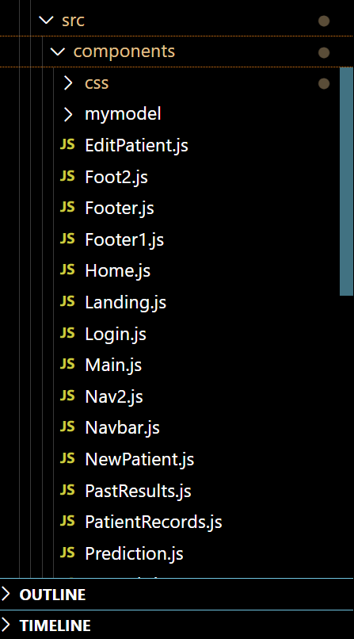

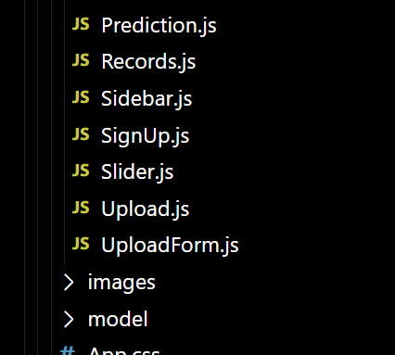

LOADING THE MODEL:

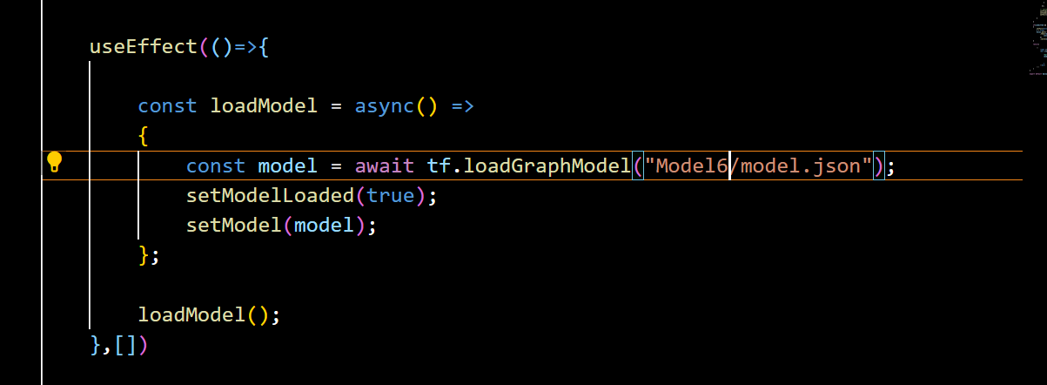

WHEN THE IMAGE IS UPLOADED:

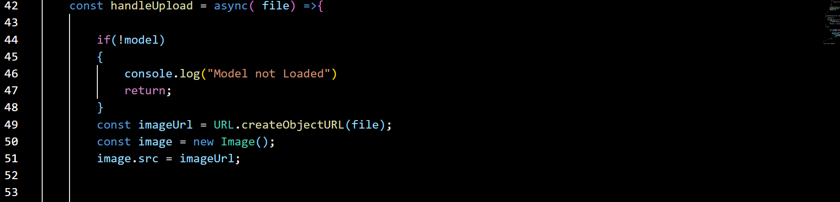

PREPROCESSING THE UPLOADED IMAGE AND STORING THE PREDICTIONS:

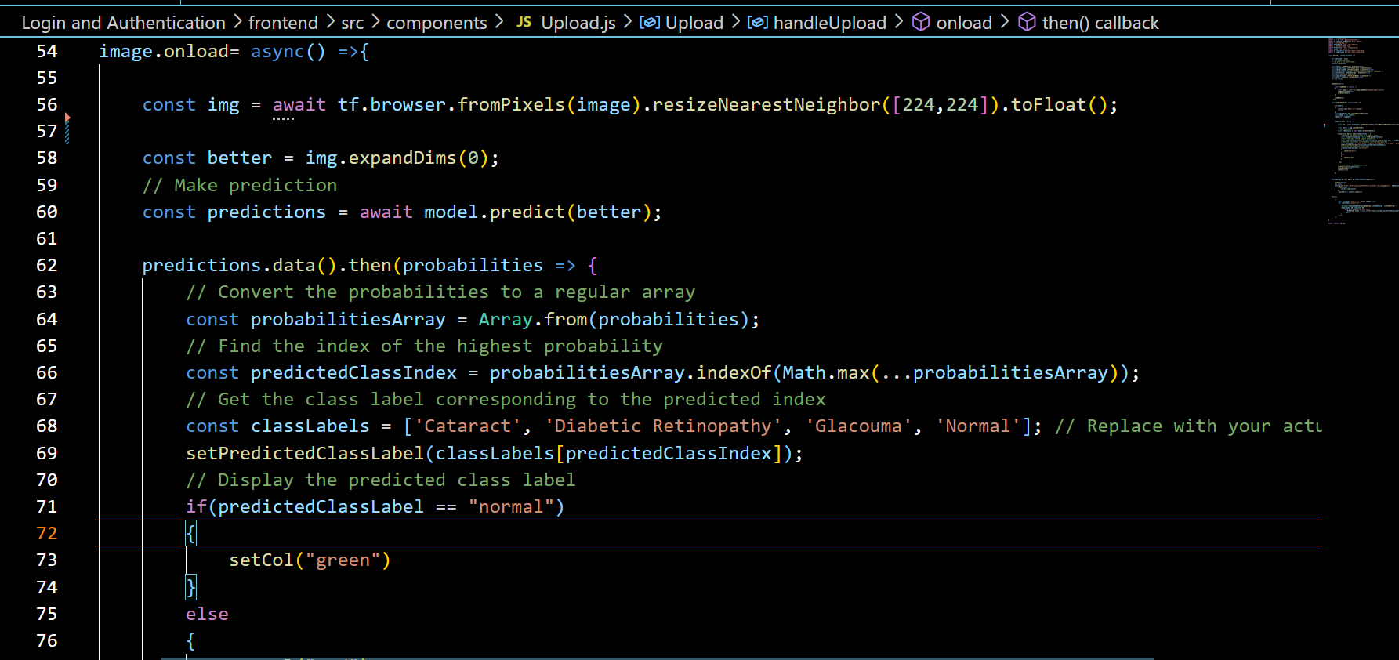

BACKEND COMPONENTS:

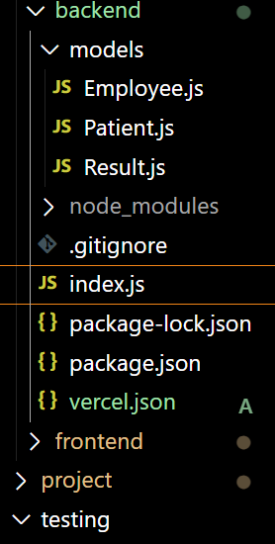

APP. JS PAGE:

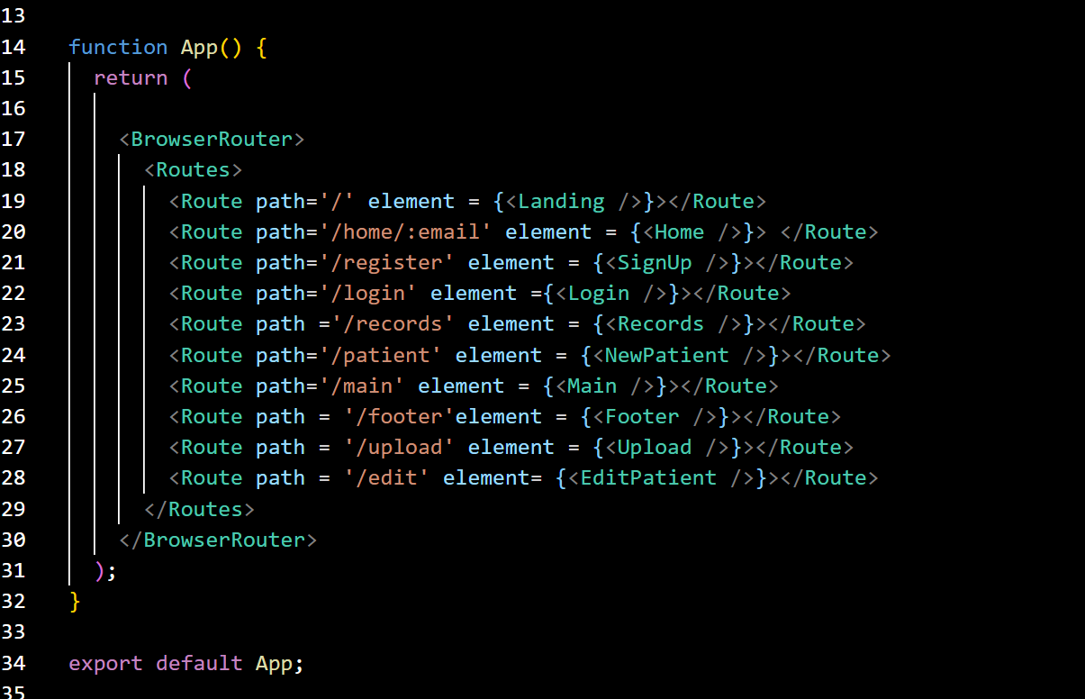

**Activity 3: Run the application**

* Click the deployment link and open it
* First , signup and create your account
* Then, login using your credentials
* Then, you have two options, either to create a new patient and click the button for that or view your existing patient records.
* If you click on register a new patient , then you have to enter the details of a new paitent and then click on submit to create a patient.
* All the patients detials along with the result of their past classification will be displayed in table format.
* You have the option of deleting or updating a certain patient record.
* If you click on upload image for a certain patient record, you will be redirected to the upload image section where you will have to upload image and the result of that classfication of that result will be stored for the same patient.



INPUT 1:

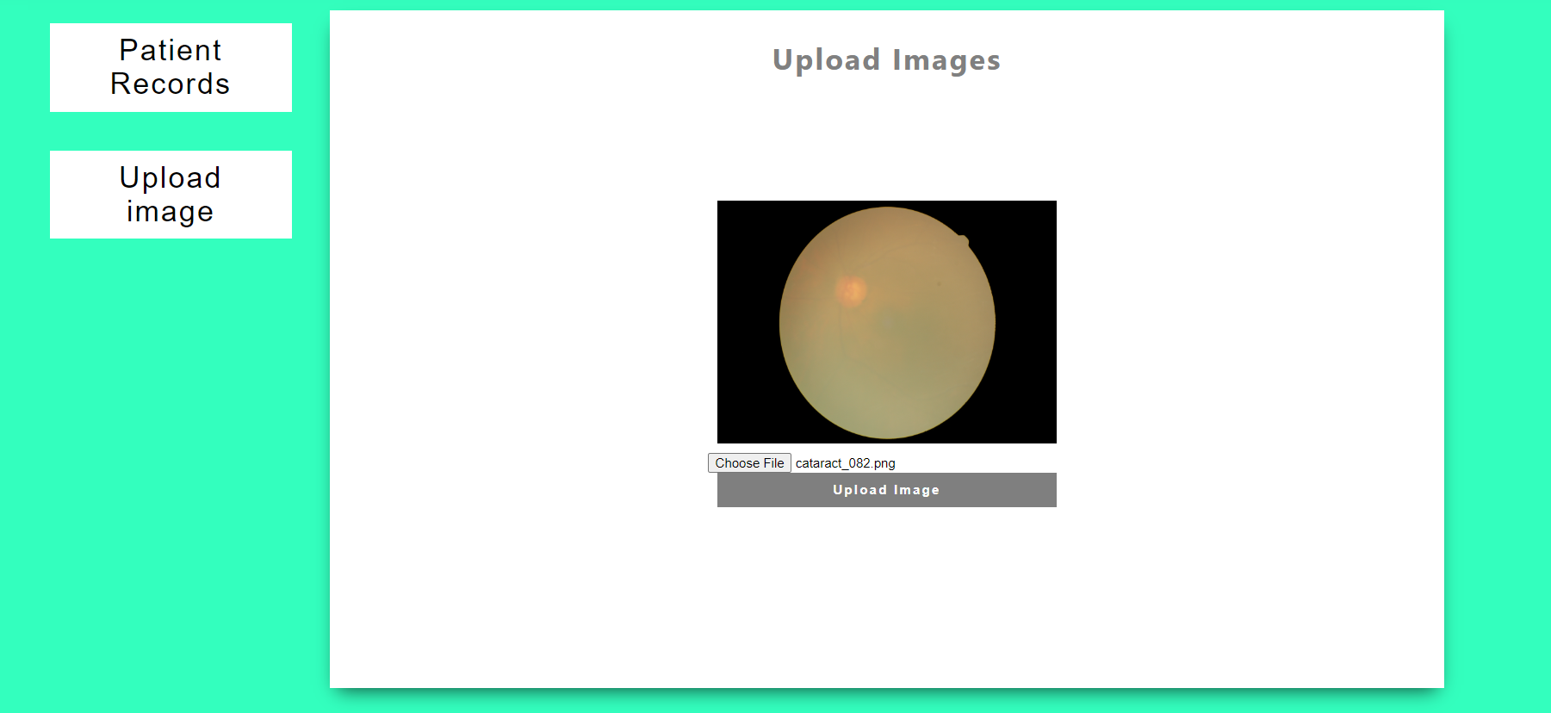

Click on the upload image button and then it will display the result

OUTPUT 1:

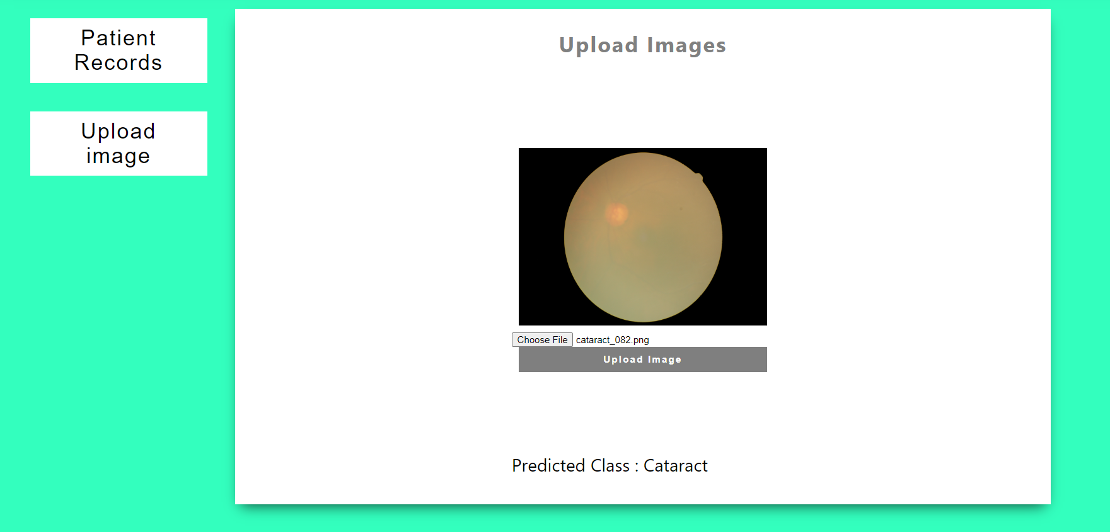

INPUT 2:

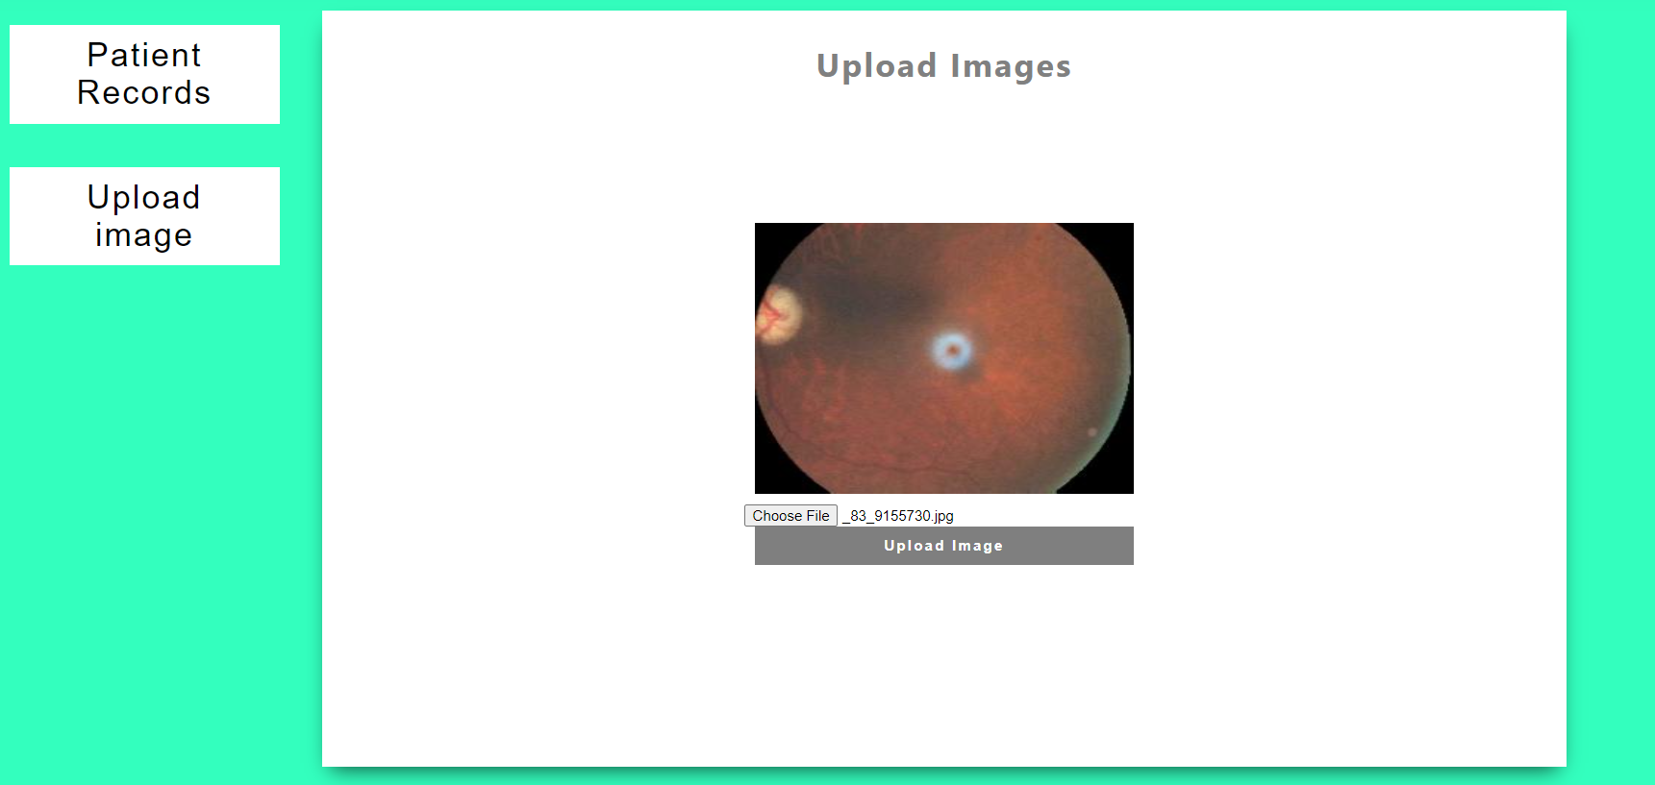

OUTPUT 2:

